UNITED STATES
SECURITIES AND EXCHANGE COMMISSION
Washington, D.C. 20549

FORM 8-K

CURRENT REPORT

Pursuant to Section 13 OR 15(d) of The Securities Exchange Act of 1934

Date of Report (Date of earliest event reported): September 14, 2026

Niki BioSolutions, Inc.
(Exact name of Registrant as Specified in Its Charter)

Delaware |  | 001-38764 |  | 42-3265309
(State or Other Jurisdiction  of Incorporation) |  | (Commission File Number) |  | (IRS Employer  Identification No.)

116 Village Boulevard, Suite 200, Princeton, NJ 08540
(Address of Principal Executive Offices, including zip code)

Registrant’s Telephone Number, Including Area Code: 609-951-2222

Aptorum Group Limited
17 Hanover Square
London W1S 1BN, United Kingdom
(Former Name or Former Address, if Changed Since Last Report)

Check the appropriate box below if the Form 8-K filing is intended to simultaneously satisfy the filing obligation of the registrant under any of the following provisions:

☐ | Written communications pursuant to Rule 425 under the Securities Act (17 CFR 230.425)

☐ | Soliciting material pursuant to Rule 14a-12 under the Exchange Act (17 CFR 240.14a-12)

☐ | Pre-commencement communications pursuant to Rule 14d-2(b) under the Exchange Act (17 CFR 240.14d-2(b))

☐ | Pre-commencement communications pursuant to Rule 13e-4(c) under the Exchange Act (17 CFR 240.13e-4(c))

Securities registered pursuant to Section 12(b) of the Act:

Title of each class |  | Trading Symbol(s) |  | Name of each exchange on which registered
Common stock, par value $0.0001 per share |  | NIKI |  | The Nasdaq Capital Market

Indicate by check mark whether the registrant is an emerging growth company as defined in Rule 405 of the Securities Act of 1933 (§ 230.405 of this chapter) or Rule 12b-2 of the Securities Exchange Act of 1934 (§ 240.12b-2 of this chapter).

Emerging growth company ☐

If an emerging growth company, indicate by check mark if the registrant has elected not to use the extended transition period for complying with any new or revised financial accounting standards provided pursuant to Section 13(a) of the Exchange Act. ☐

Item 8.01 Other Events.

We are filing this report to disclose our corporate PowerPoint presentation. The presentation is furnished as an exhibit to this Current Report on Form 8-K.

Neither this report nor the exhibit attached hereto constitute an offer to sell, or the solicitation of an offer to buy our securities, nor shall there be any sale of our securities in any state or jurisdiction in which such offer, solicitation or sale would be unlawful prior to the registration or qualification under the securities laws of any such state or jurisdiction.

Item 9.01. Financial Statements and Exhibits.

(d) Exhibits.

Exhibit |  | Description
99.1 |  | Presentation
104 |  | Cover Page Interactive Data File, formatted in Inline XBRL

1

SIGNATURE

Pursuant to the requirements of the Securities Exchange Act of 1934, the registrant has duly caused this report to be signed on its behalf by the undersigned hereunto duly authorized.

Dated: September 14, 2026

 | NIKI BIOSOLUTIONS, INC.
 | By: | /s/ Ian Huen
 |  | Ian Huen
 |  | Chief Executive Officer

2

Exhibit 99.1

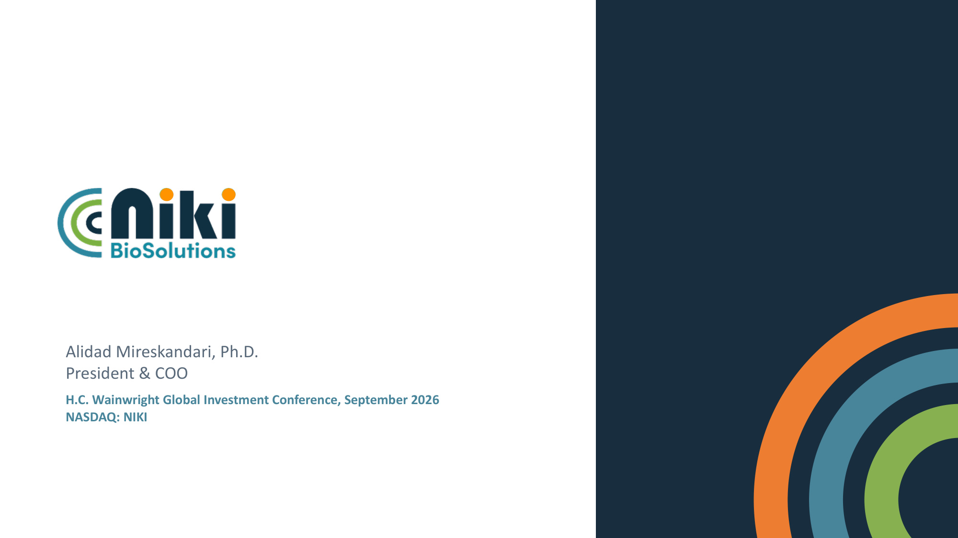
Alidad Mireskandari, Ph.D. President & COO H.C. Wainwright Global Investment Conference, September 2026 NASDAQ: NIKI

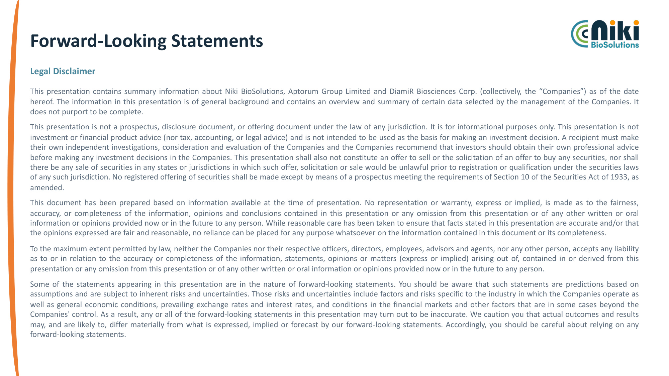
Forward-Looking Statements Legal Disclaimer This presentation contains summary information about Niki BioSolutions, Aptorum Group Limited and DiamiR Biosciences Corp. (collectively, the "Companies") as of the date hereof. The information in this presentation is of general background and contains an overview and summary of certain data selected by the management of the Companies. It does not purport to be complete. This presentation is not a prospectus, disclosure document, or offering document under the law of any jurisdiction. It is for informational purposes only. This presentation is not investment or financial product advice (nor tax, accounting, or legal advice) and is not intended to be used as the basis for making an investment decision. A recipient must make their own independent investigations, consideration and evaluation of the Companies and the Companies recommend that investors should obtain their own professional advice before making any investment decisions in the Companies. This presentation shall also not constitute an offer to sell or the solicitation of an offer to buy any securities, nor shall there be any sale of securities in any states or jurisdictions in which such offer, solicitation or sale would be unlawful prior to registration or qualification under the securities laws of any such jurisdiction. No registered offering of securities shall be made except by means of a prospectus meeting the requirements of Section 10 of the Securities Act of 1933, as amended. This document has been prepared based on information available at the time of presentation. No representation or warranty, express or implied, is made as to the fairness, accuracy, or completeness of the information, opinions and conclusions contained in this presentation or any omission from this presentation or of any other written or oral information or opinions provided now or in the future to any person. While reasonable care has been taken to ensure that facts stated in this presentation are accurate and/or that the opinions expressed are fair and reasonable, no reliance can be placed for any purpose whatsoever on the information contained in this document or its completeness. To the maximum extent permitted by law, neither the Companies nor their respective officers, directors, employees, advisors and agents, nor any other person, accepts any liability as to or in relation to the accuracy or completeness of the information, statements, opinions or matters (express or implied) arising out of, contained in or derived from this presentation or any omission from this presentation or of any other written or oral information or opinions provided now or in the future to any person. Some of the statements appearing in this presentation are in the nature of forward-looking statements. You should be aware that such statements are predictions based on assumptions and are subject to inherent risks and uncertainties. Those risks and uncertainties include factors and risks specific to the industry in which the Companies operate as well as general economic conditions, prevailing exchange rates and interest rates, and conditions in the financial markets and other factors that are in some cases beyond the Companies' control. As a result, any or all of the forward-looking statements in this presentation may turn out to be inaccurate. We caution you that actual outcomes and results may, and are likely to, differ materially from what is expressed, implied or forecast by our forward-looking statements. Accordingly, you should be careful about relying on any forward-looking statements.

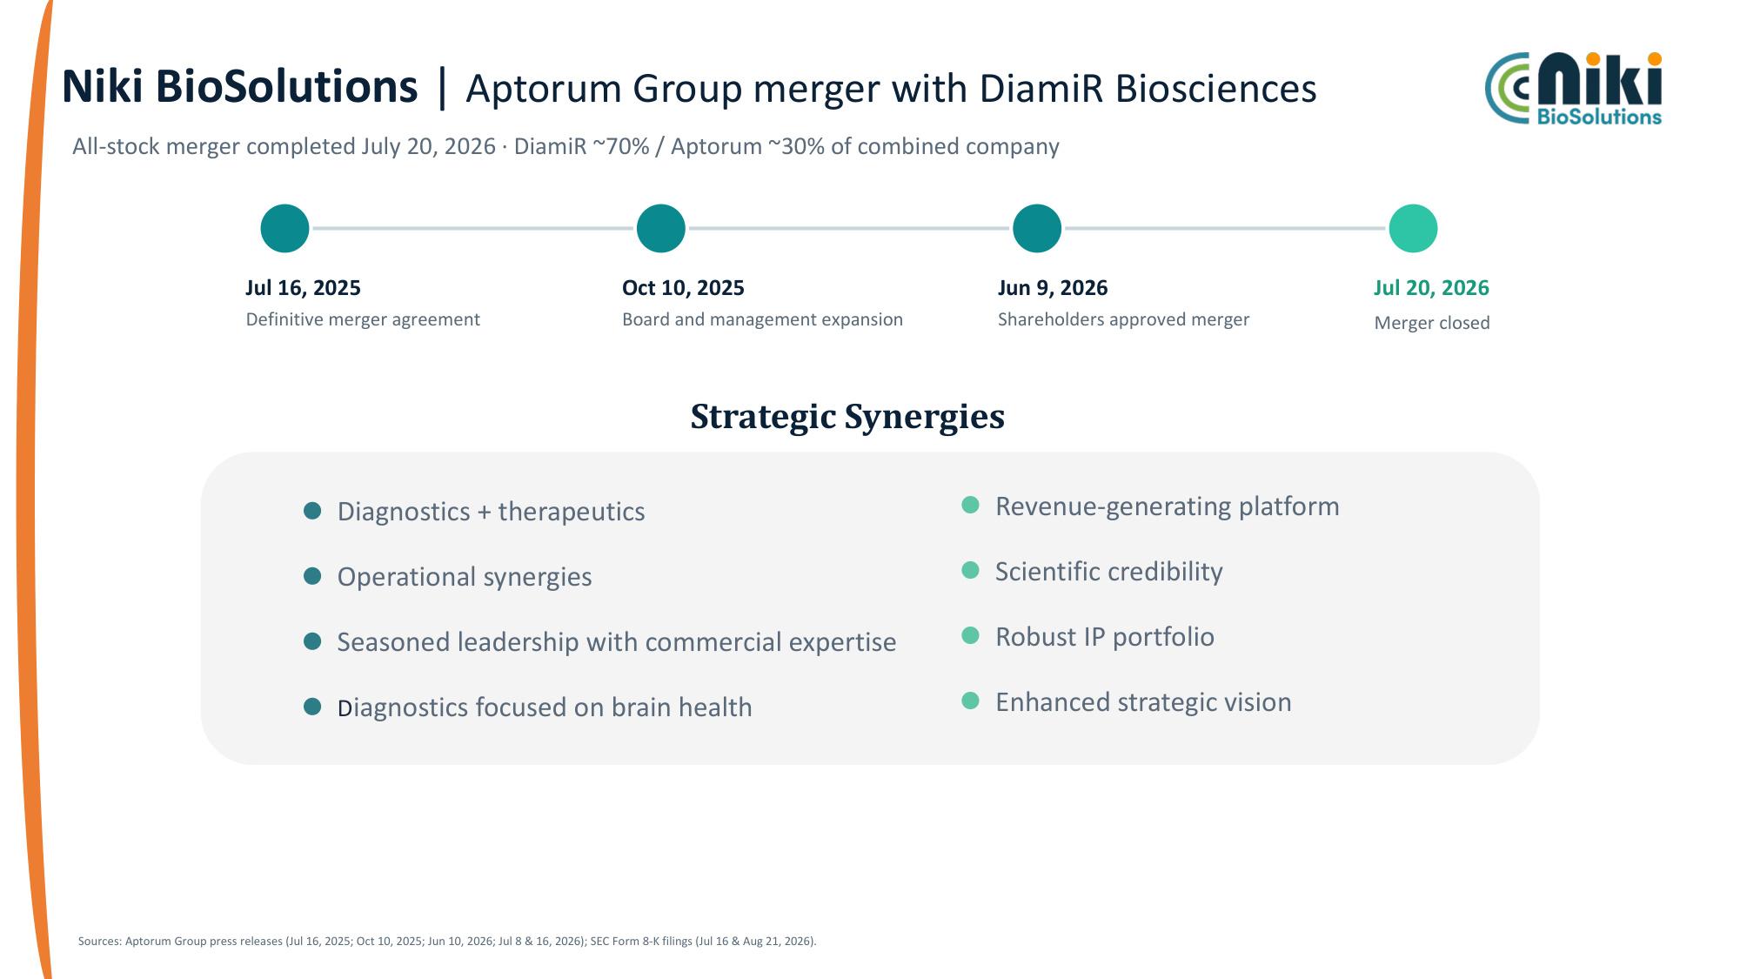
Niki BioSolutions | Aptorum Group merger with DiamiR Biosciences All-stock merger completed July 20, 2026 · DiamiR ~70% / Aptorum ~30% of combined company Jul 16, 2025 Definitive merger agreement Oct 10, 2025 Board and management expansion Jun 9, 2026 Shareholders approved merger Jul 20, 2026 Merger closed Sources: Aptorum Group press releases (Jul 16, 2025; Oct 10, 2025; Jun 10, 2026; Jul 8 & 16, 2026); SEC Form 8-K filings (Jul 16 & Aug 21, 2026). Strategic Synergies Diagnostics + therapeutics Operational synergies Seasoned leadership with commercial expertise Diagnostics focused on brain health Revenue-generating platform Scientific credibility Robust IP portfolio Enhanced strategic vision

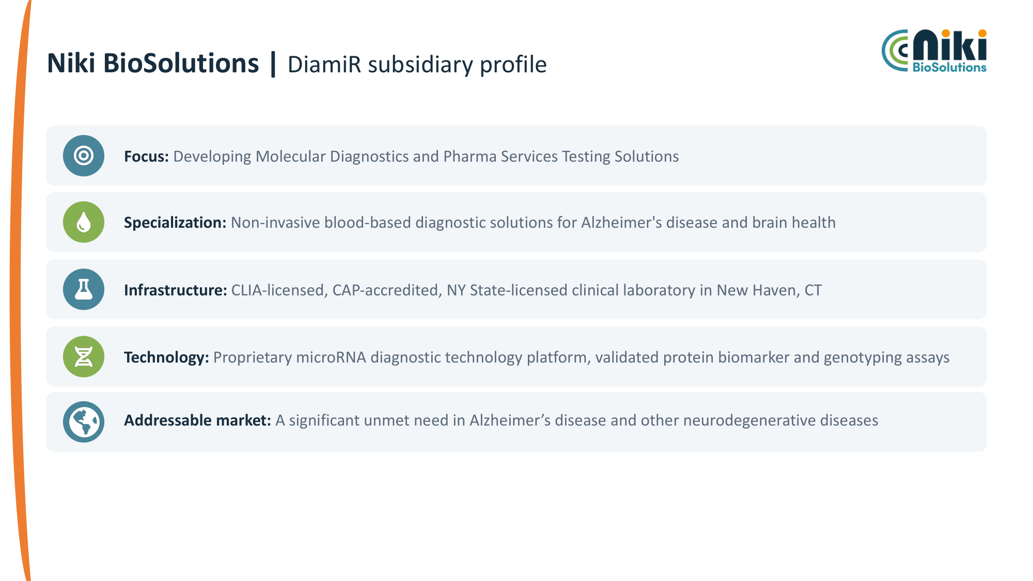
Niki BioSolutions | DiamiR subsidiary profile Focus: Developing Molecular Diagnostics and Pharma Services Testing Solutions Specialization: Non-invasive blood-based diagnostic solutions for Alzheimer's disease and brain health Infrastructure: CLIA-licensed, CAP-accredited, NY State-licensed clinical laboratory in New Haven, CT Technology: Proprietary microRNA diagnostic technology platform, validated protein biomarker and genotyping assays Addressable market: A significant unmet need in Alzheimer's disease and other neurodegenerative diseases

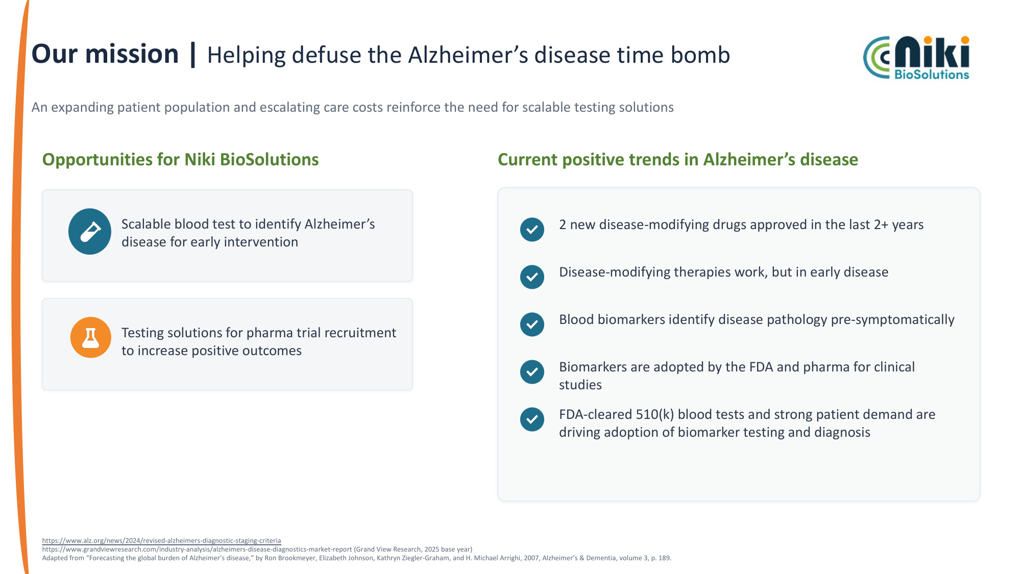
Our mission | Helping defuse the Alzheimer's disease time bomb An expanding patient population and escalating care costs reinforce the need for scalable testing solutions Opportunities for Niki BioSolutions Scalable blood test to identify Alzheimer's disease for early intervention Testing solutions for pharma trial recruitment to increase positive outcomes Current positive trends in Alzheimer's disease 2 new disease-modifying drugs approved in the last 2+ years Disease-modifying therapies work, but in early disease Blood biomarkers identify disease pathology pre-symptomatically Biomarkers are adopted by the FDA and pharma for clinical studies FDA-cleared 510(k) blood tests and strong patient demand are driving adoption of biomarker testing and diagnosis https://www.alz.org/news/2024/revised-alzheimers-diagnostic-staging-criteria https://www.grandviewresearch.com/industry-analysis/alzheimers-disease-diagnostics-market-report (Grand View Research, 2025 base year) Adapted from "Forecasting the global burden of Alzheimer's disease," by Ron Brookmeyer, Elizabeth Johnson, Kathryn Ziegler-Graham, and H. Michael Arrighi, 2007, Alzheimer's & Dementia, volume 3, p. 189.

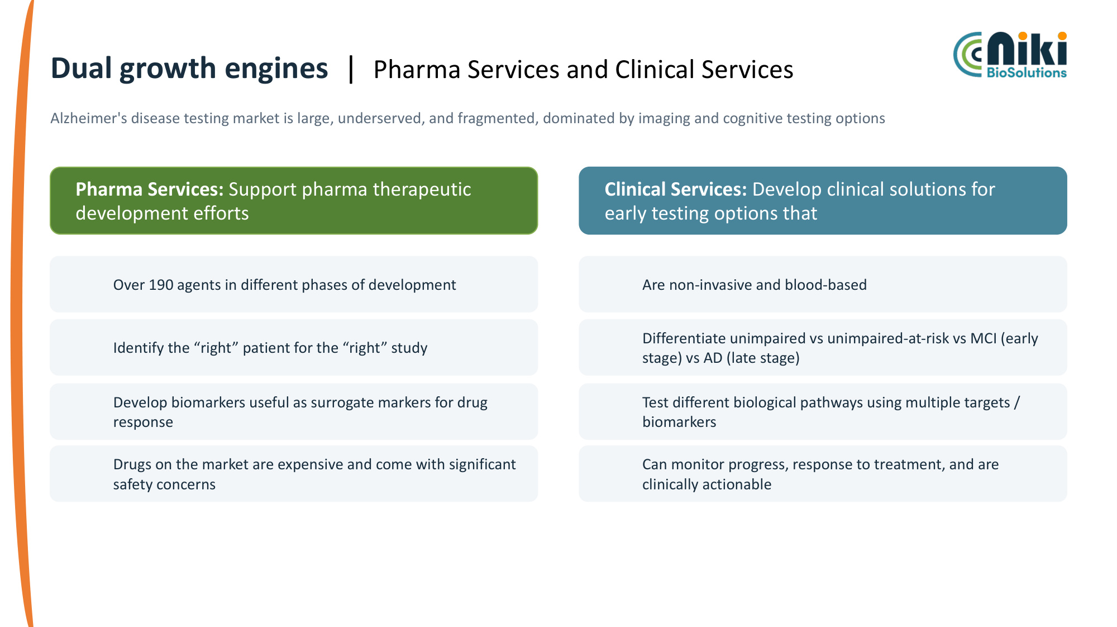
Dual growth engines | Pharma Services and Clinical Services Alzheimer's disease testing market is large, underserved, and fragmented, dominated by imaging and cognitive testing options Clinical Services: Develop clinical solutions for early testing options that Are non-invasive and blood-based Differentiate unimpaired vs unimpaired-at-risk vs MCI (early stage) vs AD (late stage) Test different biological pathways using multiple targets / biomarkers Can monitor progress, response to treatment, and are clinically actionable Pharma Services: Support pharma therapeutic development efforts Over 190 agents in different phases of development Identify the "right" patient for the "right" study Develop biomarkers useful as surrogate markers for drug response Drugs on the market are expensive and come with significant safety concerns

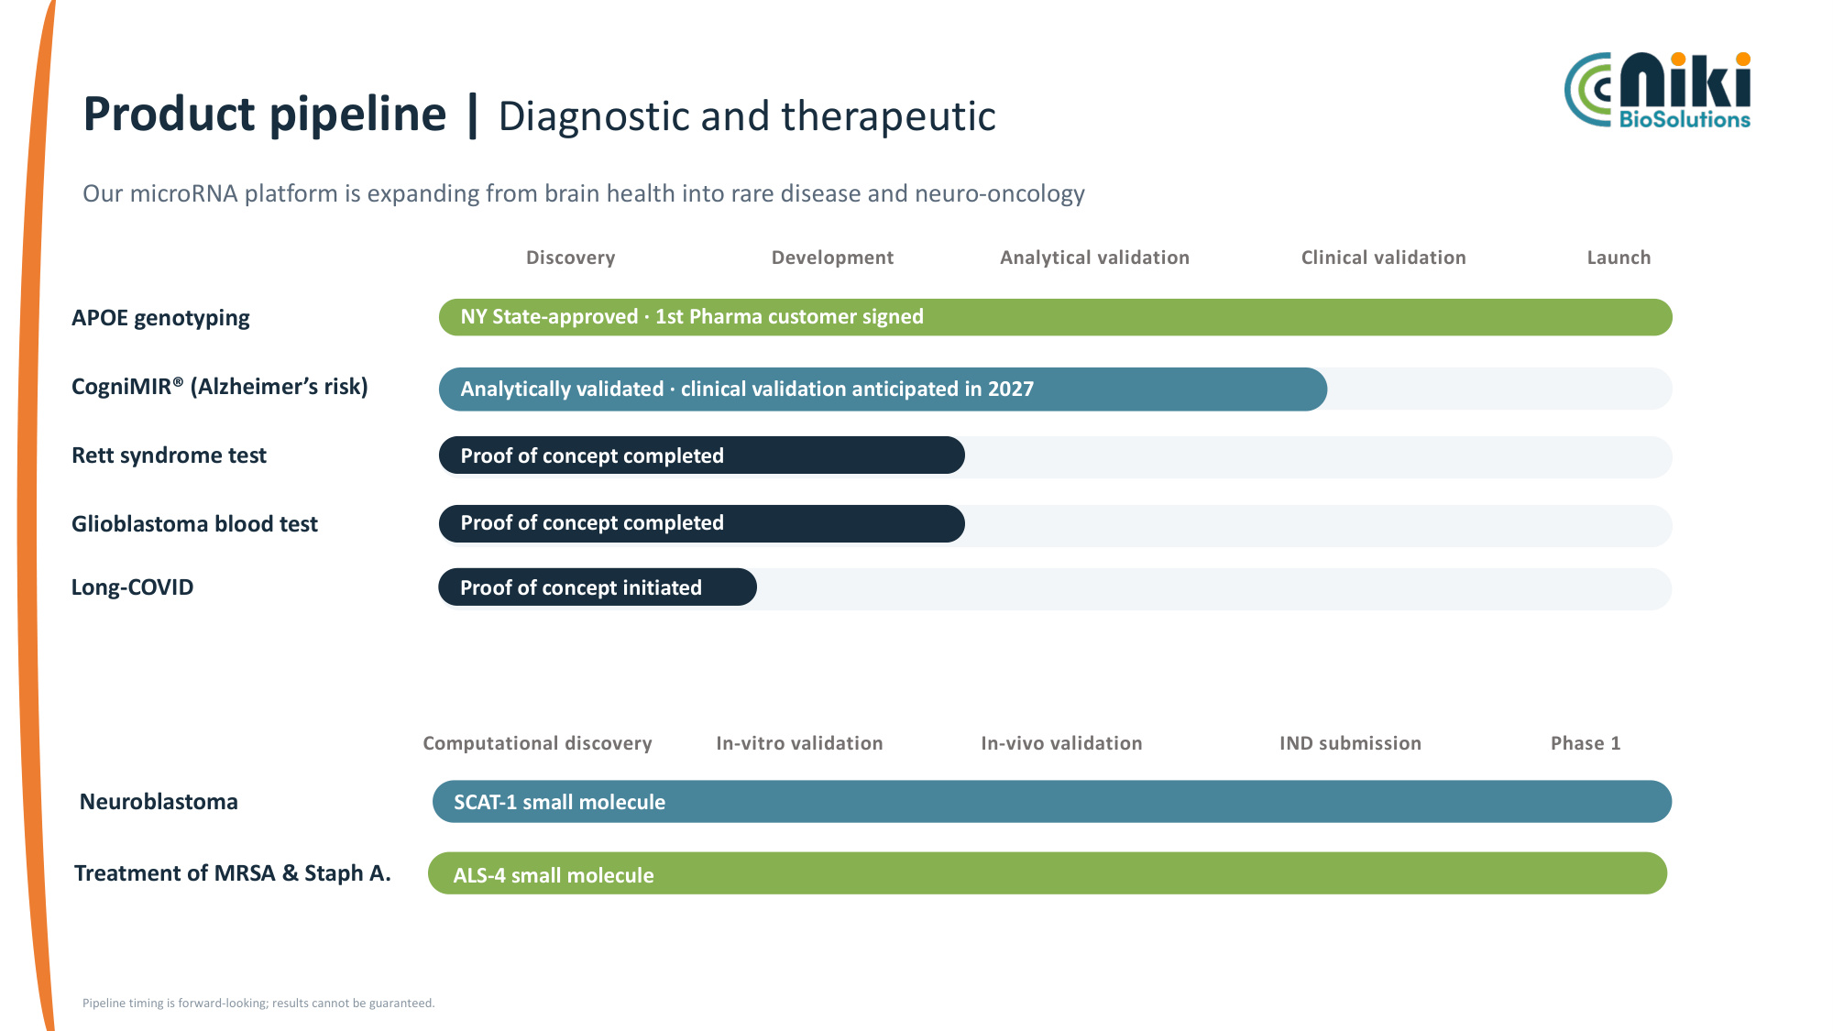
Product pipeline | Diagnostic and therapeutic Our microRNA platform is expanding from brain health into rare disease and neuro-oncology Discovery Development Analytical validation Clinical validation Launch APOE genotyping NY State-approved · 1st Pharma customer signed CogniMIR® (Alzheimer's risk) Analytically validated · clinical validation anticipated in 2027 Rett syndrome test Proof of concept completed Glioblastoma blood test Proof of concept completed Pipeline timing is forward-looking; results cannot be guaranteed. Long-COVID Proof of concept initiated Computational discovery In-vitro validation In-vivo validation IND submission Phase 1 Neuroblastoma SCAT-1 small molecule Treatment of MRSA & Staph A. ALS-4 small molecule

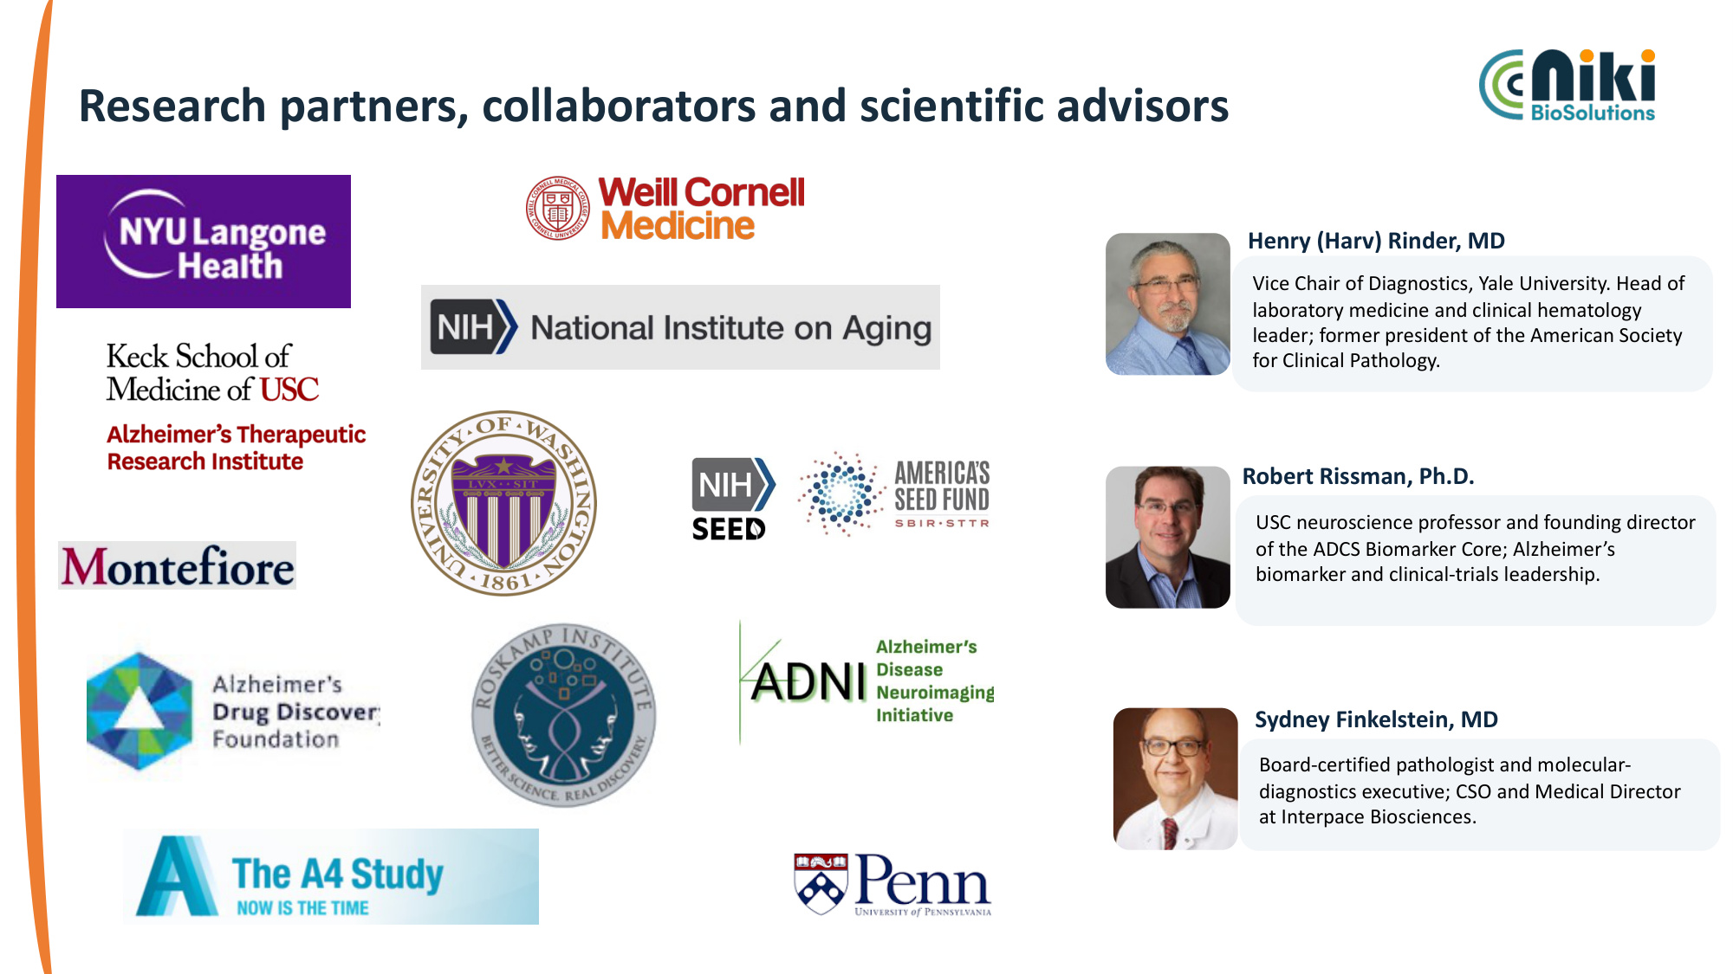
Research partners, collaborators and scientific advisors Henry (Harv) Rinder, MD Vice Chair of Diagnostics, Yale University. Head of laboratory medicine and clinical hematology leader; former president of the American Society for Clinical Pathology. Robert Rissman, Ph.D. USC neuroscience professor and founding director of the ADCS Biomarker Core; Alzheimer's biomarker and clinical-trials leadership. Sydney Finkelstein, MD Board-certified pathologist and molecular- diagnostics executive; CSO and Medical Director at Interpace Biosciences.

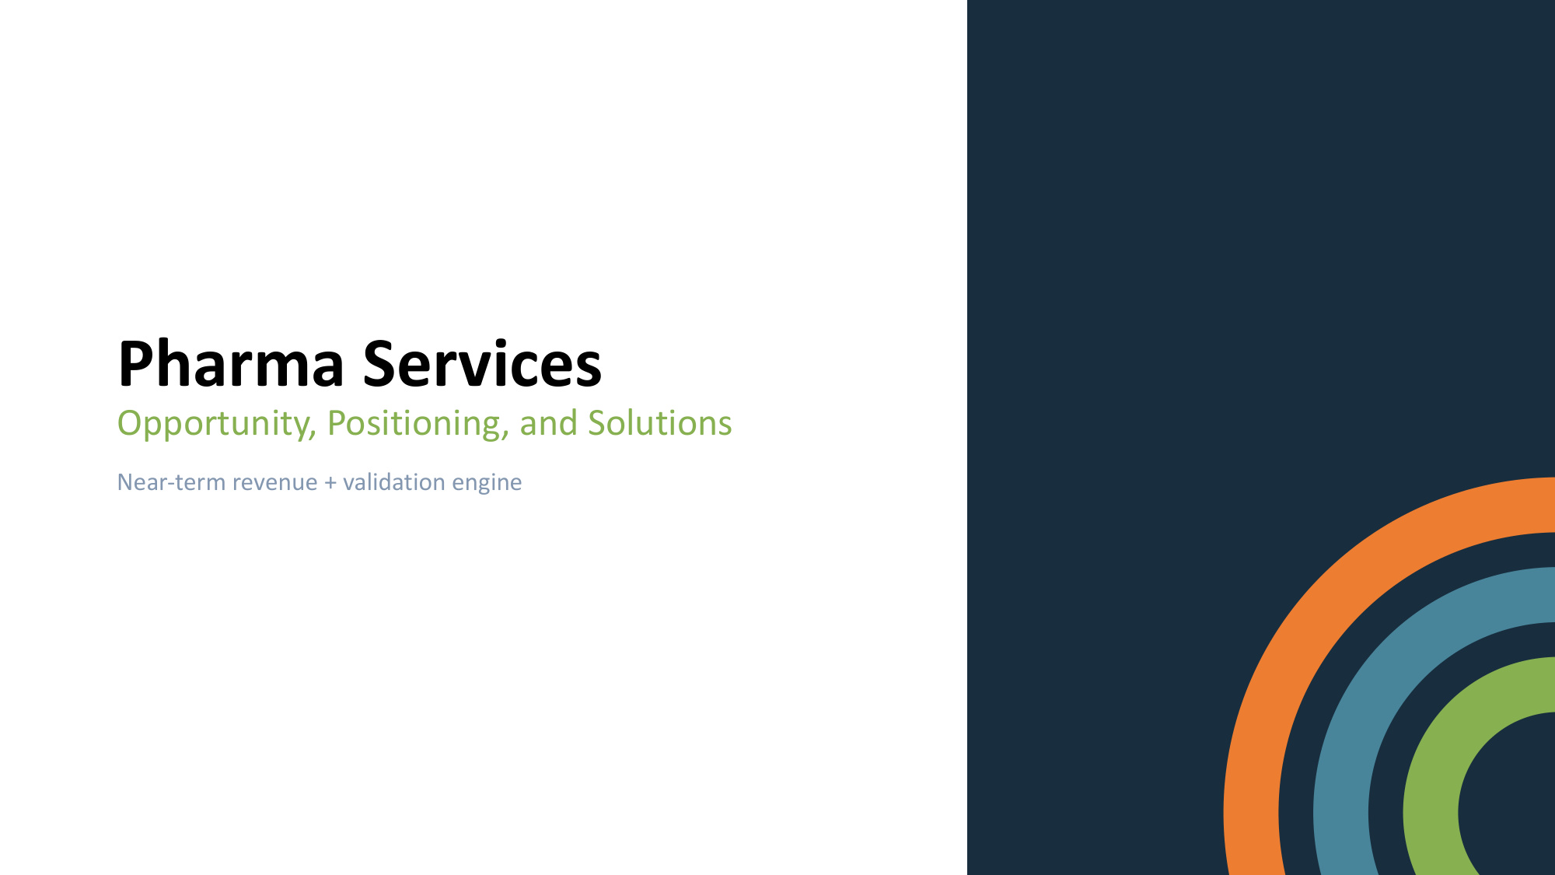
Pharma Services Opportunity, Positioning, and Solutions Near-term revenue + validation engine

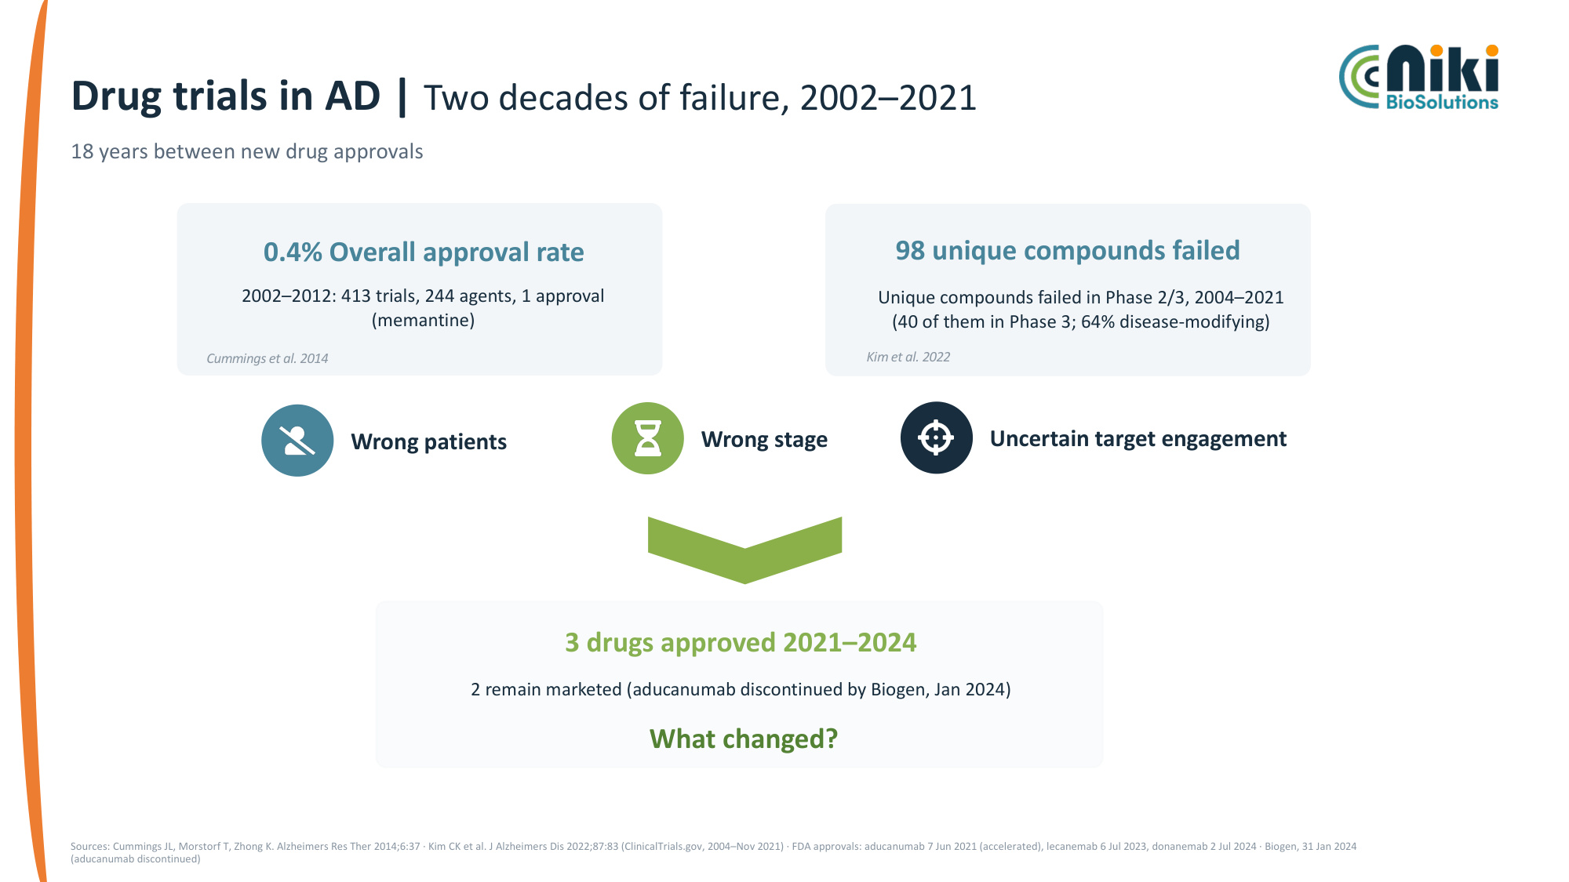
Drug trials in AD | Two decades of failure, 2002–2021 18 years between new drug approvals 0.4% Overall approval rate 2002–2012: 413 trials, 244 agents, 1 approval (memantine) Cummings et al. 2014 98 unique compounds failed Unique compounds failed in Phase 2/3, 2004–2021 (40 of them in Phase 3; 64% disease-modifying) Kim et al. 2022 3 drugs approved 2021–2024 2 remain marketed (aducanumab discontinued by Biogen, Jan 2024) Sources: Cummings JL, Morstorf T, Zhong K. Alzheimers Res Ther 2014;6:37 · Kim CK et al. J Alzheimers Dis 2022;87:83 (ClinicalTrials.gov, 2004–Nov 2021) · FDA approvals: aducanumab 7 Jun 2021 (accelerated), lecanemab 6 Jul 2023, donanemab 2 Jul 2024 · Biogen, 31 Jan 2024 (aducanumab discontinued) Wrong patients Wrong stage Uncertain target engagement What changed?

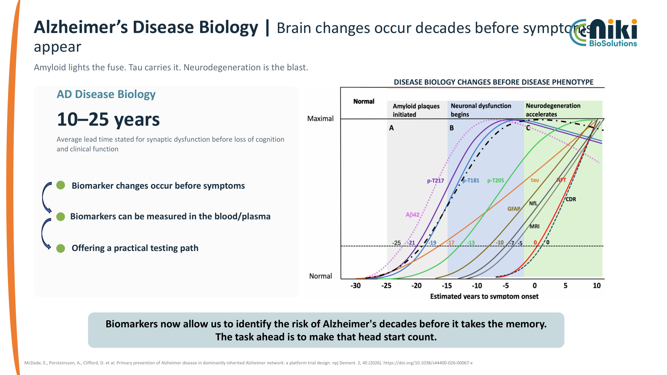
Alzheimer's Disease Biology | Brain changes occur decades before symptoms appear AD Disease Biology 10–25 years Average lead time stated for synaptic dysfunction before loss of cognition and clinical function Biomarker changes occur before symptoms Biomarkers can be measured in the blood/plasma Offering a practical testing path DISEASE BIOLOGY CHANGES BEFORE DISEASE PHENOTYPE McDade, E., Porsteinsson, A., Clifford, D. et al. Primary prevention of Alzheimer disease in dominantly inherited Alzheimer network: a platform trial design. npj Dement. 2, 40 (2026). https://doi.org/10.1038/s44400-026-00067-x Amyloid lights the fuse. Tau carries it. Neurodegeneration is the blast. Biomarkers now allow us to identify the risk of Alzheimer's decades before it takes the memory. The task ahead is to make that head start count.

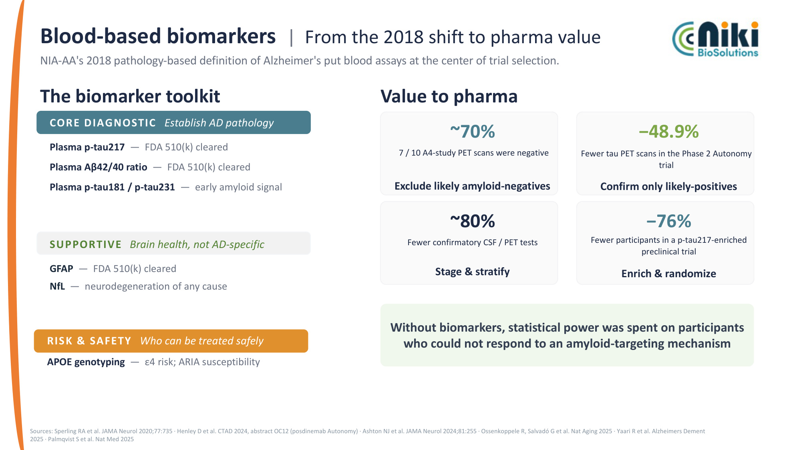
Blood-based biomarkers | From the 2018 shift to pharma value NIA-AA's 2018 pathology-based definition of Alzheimer's put blood assays at the center of trial selection. The biomarker toolkit CORE DIAGNOSTIC Establish AD pathology Plasma p-tau217 — FDA 510(k) cleared Plasma Aβ42/40 ratio — FDA 510(k) cleared Plasma p-tau181 / p-tau231 — early amyloid signal RISK & SAFETY Who can be treated safely APOE genotyping — ε4 risk; ARIA susceptibility Value to pharma ~70% 7 / 10 A4-study PET scans were negative −48.9% Fewer tau PET scans in the Phase 2 Autonomy trial Confirm only likely-positives ~80% Fewer confirmatory CSF / PET tests Stage & stratify −76% Fewer participants in a p-tau217-enriched preclinical trial Enrich & randomize Sources: Sperling RA et al. JAMA Neurol 2020;77:735 · Henley D et al. CTAD 2024, abstract OC12 (posdinemab Autonomy) · Ashton NJ et al. JAMA Neurol 2024;81:255 · Ossenkoppele R, Salvadó G et al. Nat Aging 2025 · Yaari R et al. Alzheimers Dement 2025 · Palmqvist S et al. Nat Med 2025 Exclude likely amyloid-negatives Without biomarkers, statistical power was spent on participants who could not respond to an amyloid-targeting mechanism SUPPORTIVE Brain health, not AD-specific GFAP — FDA 510(k) cleared NfL — neurodegeneration of any cause

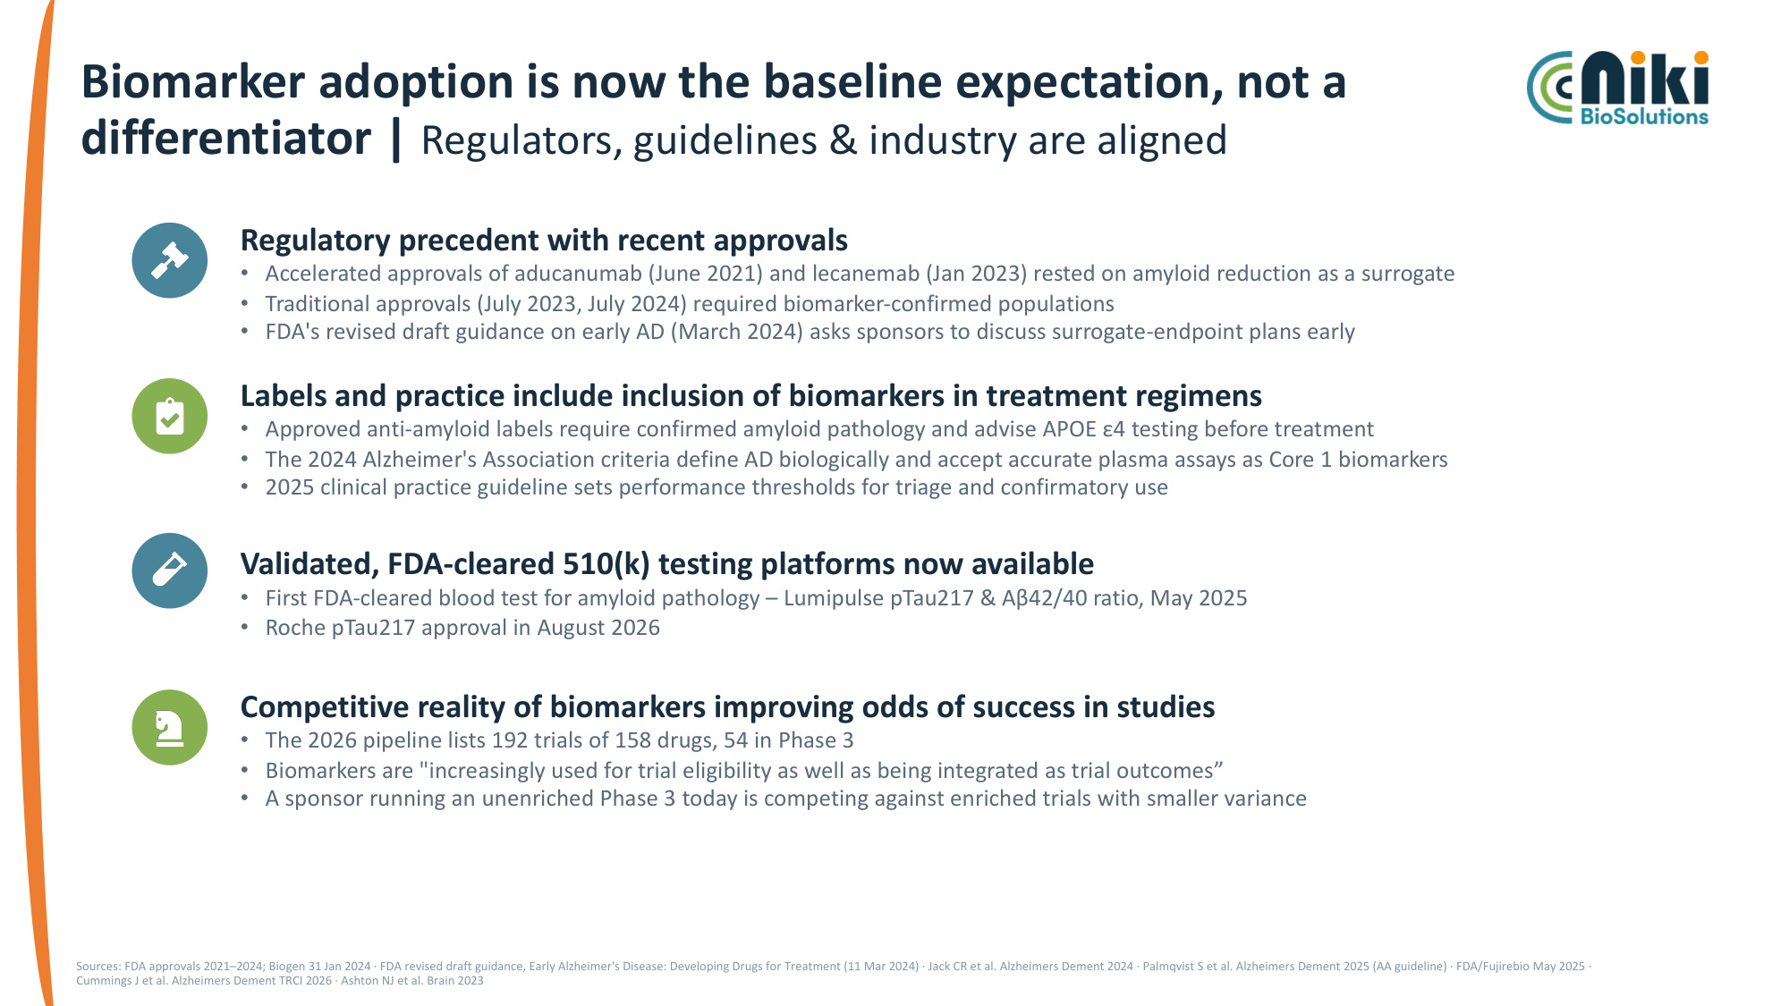
Biomarker adoption is now the baseline expectation, not a differentiator | Regulators, guidelines & industry are aligned Regulatory precedent with recent approvals • Accelerated approvals of aducanumab (June 2021) and lecanemab (Jan 2023) rested on amyloid reduction as a surrogate • Traditional approvals (July 2023, July 2024) required biomarker-confirmed populations • FDA's revised draft guidance on early AD (March 2024) asks sponsors to discuss surrogate-endpoint plans early Labels and practice include inclusion of biomarkers in treatment regimens • Approved anti-amyloid labels require confirmed amyloid pathology and advise APOE ε4 testing before treatment • The 2024 Alzheimer's Association criteria define AD biologically and accept accurate plasma assays as Core 1 biomarkers • 2025 clinical practice guideline sets performance thresholds for triage and confirmatory use Validated, FDA-cleared 510(k) testing platforms now available • First FDA-cleared blood test for amyloid pathology – Lumipulse pTau217 & Aβ42/40 ratio, May 2025 • Roche pTau217 approval in August 2026 Competitive reality of biomarkers improving odds of success in studies • The 2026 pipeline lists 192 trials of 158 drugs, 54 in Phase 3 • Biomarkers are "increasingly used for trial eligibility as well as being integrated as trial outcomes" • A sponsor running an unenriched Phase 3 today is competing against enriched trials with smaller variance Sources: FDA approvals 2021–2024; Biogen 31 Jan 2024 · FDA revised draft guidance, Early Alzheimer's Disease: Developing Drugs for Treatment (11 Mar 2024) · Jack CR et al. Alzheimers Dement 2024 · Palmqvist S et al. Alzheimers Dement 2025 (AA guideline) · FDA/Fujirebio May 2025 · Cummings J et al. Alzheimers Dement TRCI 2026 · Ashton NJ et al. Brain 2023

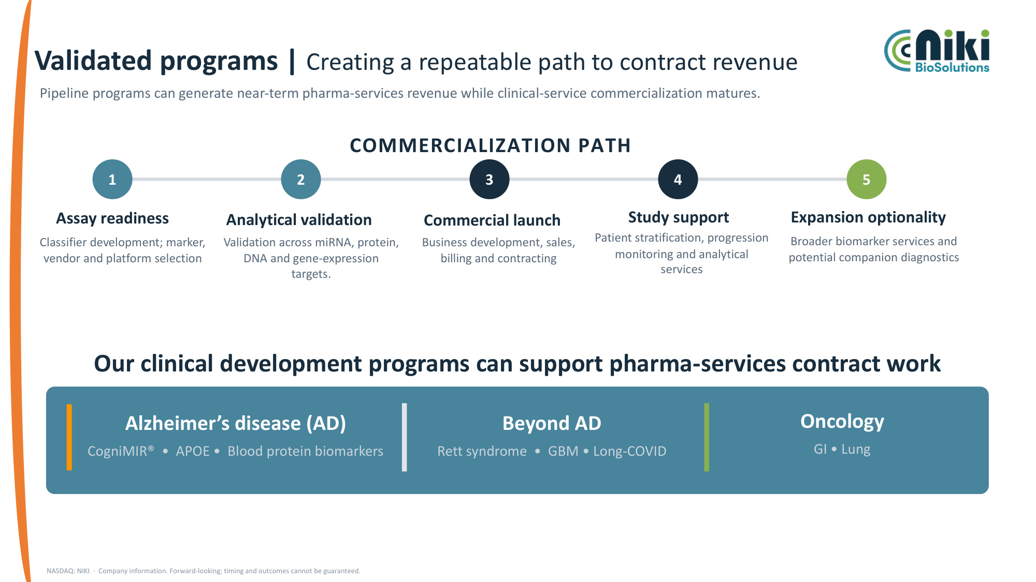
Validated programs | Creating a repeatable path to contract revenue Pipeline programs can generate near-term pharma-services revenue while clinical-service commercialization matures. COMMERCIALIZATION PATH 1 Assay readiness Classifier development; marker, vendor and platform selection 2 Analytical validation Validation across miRNA, protein, DNA and gene-expression targets. 3 Commercial launch Business development, sales, billing and contracting 4 Study support Patient stratification, progression monitoring and analytical services 5 Expansion optionality Broader biomarker services and potential companion diagnostics Our clinical development programs can support pharma-services contract work Alzheimer's disease (AD) CogniMIR® • APOE • Blood protein biomarkers Beyond AD Rett syndrome • GBM • Long-COVID Oncology GI • Lung NASDAQ: NIKI · Company information. Forward-looking; timing and outcomes cannot be guaranteed.

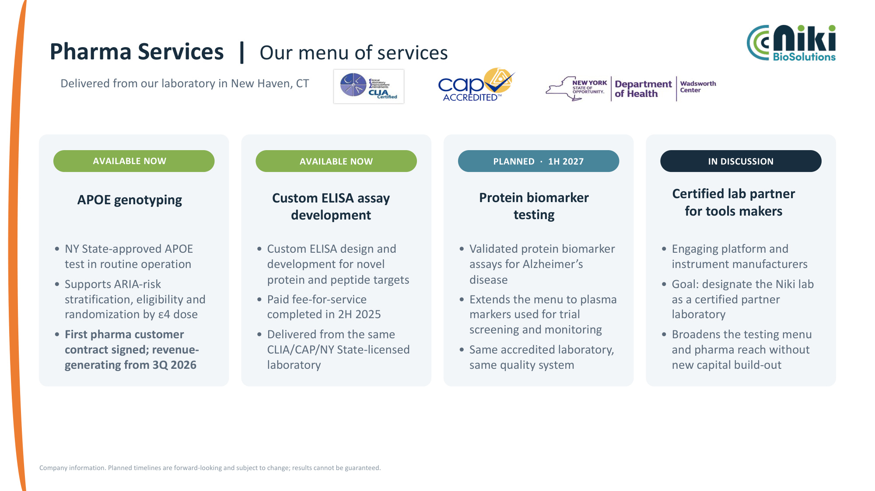
Pharma Services | Our menu of services AVAILABLE NOW APOE genotyping • NY State-approved APOE test in routine operation • Supports ARIA-risk stratification, eligibility and randomization by ε4 dose • First pharma customer contract signed; revenue- generating from 3Q 2026 AVAILABLE NOW Custom ELISA assay development • Custom ELISA design and development for novel protein and peptide targets • Paid fee-for-service completed in 2H 2025 • Delivered from the same CLIA/CAP/NY State-licensed laboratory PLANNED · 1H 2027 Protein biomarker testing • Validated protein biomarker assays for Alzheimer's disease • Extends the menu to plasma markers used for trial screening and monitoring • Same accredited laboratory, same quality system IN DISCUSSION Certified lab partner for tools makers • Engaging platform and instrument manufacturers • Goal: designate the Niki lab as a certified partner laboratory • Broadens the testing menu and pharma reach without new capital build-out Company information. Planned timelines are forward-looking and subject to change; results cannot be guaranteed. Delivered from our laboratory in New Haven, CT

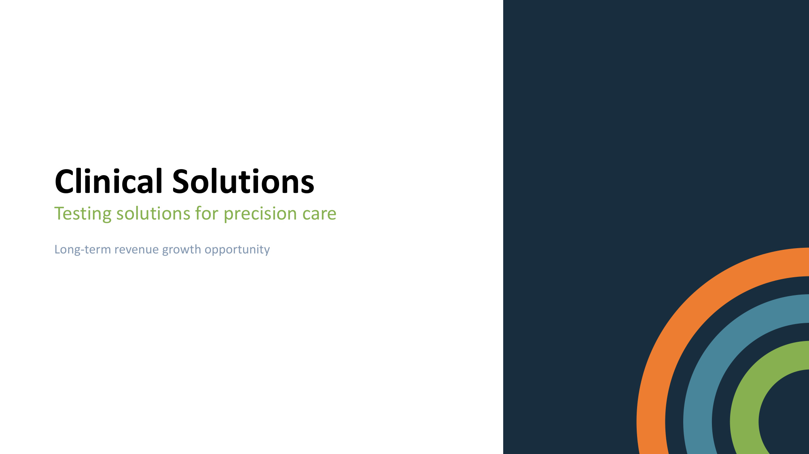
Clinical Solutions Testing solutions for precision care Long-term revenue growth opportunity

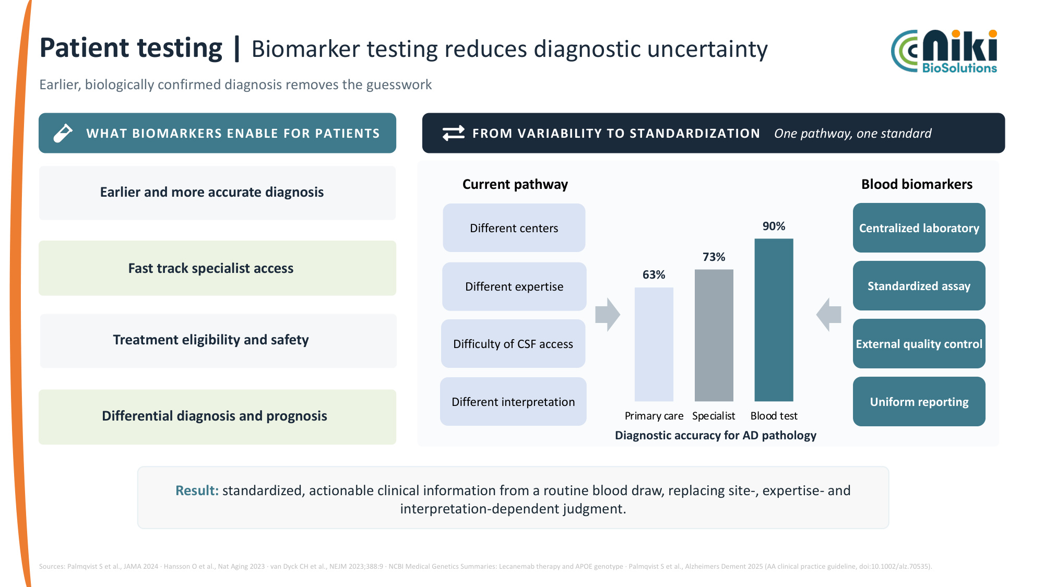
Patient testing | Biomarker testing reduces diagnostic uncertainty Earlier, biologically confirmed diagnosis removes the guesswork WHAT BIOMARKERS ENABLE FOR PATIENTS Earlier and more accurate diagnosis Treatment eligibility and safety Fast track specialist access FROM VARIABILITY TO STANDARDIZATION One pathway, one standard Current pathway Diagnostic accuracy for AD pathology Blood biomarkers Different centers Different expertise Difficulty of CSF access Different interpretation Centralized laboratory Standardized assay External quality control Uniform reporting 63% 73% 90% Primary care Specialist Blood test Result: standardized, actionable clinical information from a routine blood draw, replacing site-, expertise- and interpretation-dependent judgment. Sources: Palmqvist S et al., JAMA 2024 · Hansson O et al., Nat Aging 2023 · van Dyck CH et al., NEJM 2023;388:9 · NCBI Medical Genetics Summaries: Lecanemab therapy and APOE genotype · Palmqvist S et al., Alzheimers Dement 2025 (AA clinical practice guideline, doi:10.1002/alz.70535). Differential diagnosis and prognosis

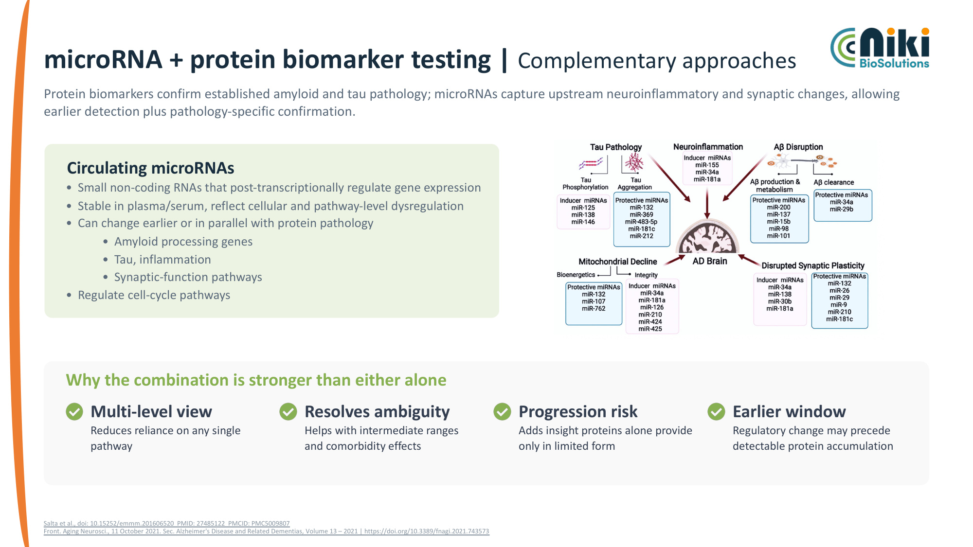
microRNA + protein biomarker testing | Complementary approaches Protein biomarkers confirm established amyloid and tau pathology; microRNAs capture upstream neuroinflammatory and synaptic changes, allowing earlier detection plus pathology-specific confirmation. Circulating microRNAs • Small non-coding RNAs that post-transcriptionally regulate gene expression • Stable in plasma/serum, reflect cellular and pathway-level dysregulation • Can change earlier or in parallel with protein pathology • Amyloid processing genes • Tau, inflammation • Synaptic-function pathways • Regulate cell-cycle pathways Why the combination is stronger than either alone Multi-level view Reduces reliance on any single pathway Resolves ambiguity Helps with intermediate ranges and comorbidity effects Progression risk Adds insight proteins alone provide only in limited form Earlier window Regulatory change may precede detectable protein accumulation Salta et al., doi: 10.15252/emmm.201606520 PMID: 27485122 PMCID: PMC5009807 Front. Aging Neurosci., 11 October 2021. Sec. Alzheimer's Disease and Related Dementias, Volume 13 – 2021 | https://doi.org/10.3389/fnagi.2021.743573

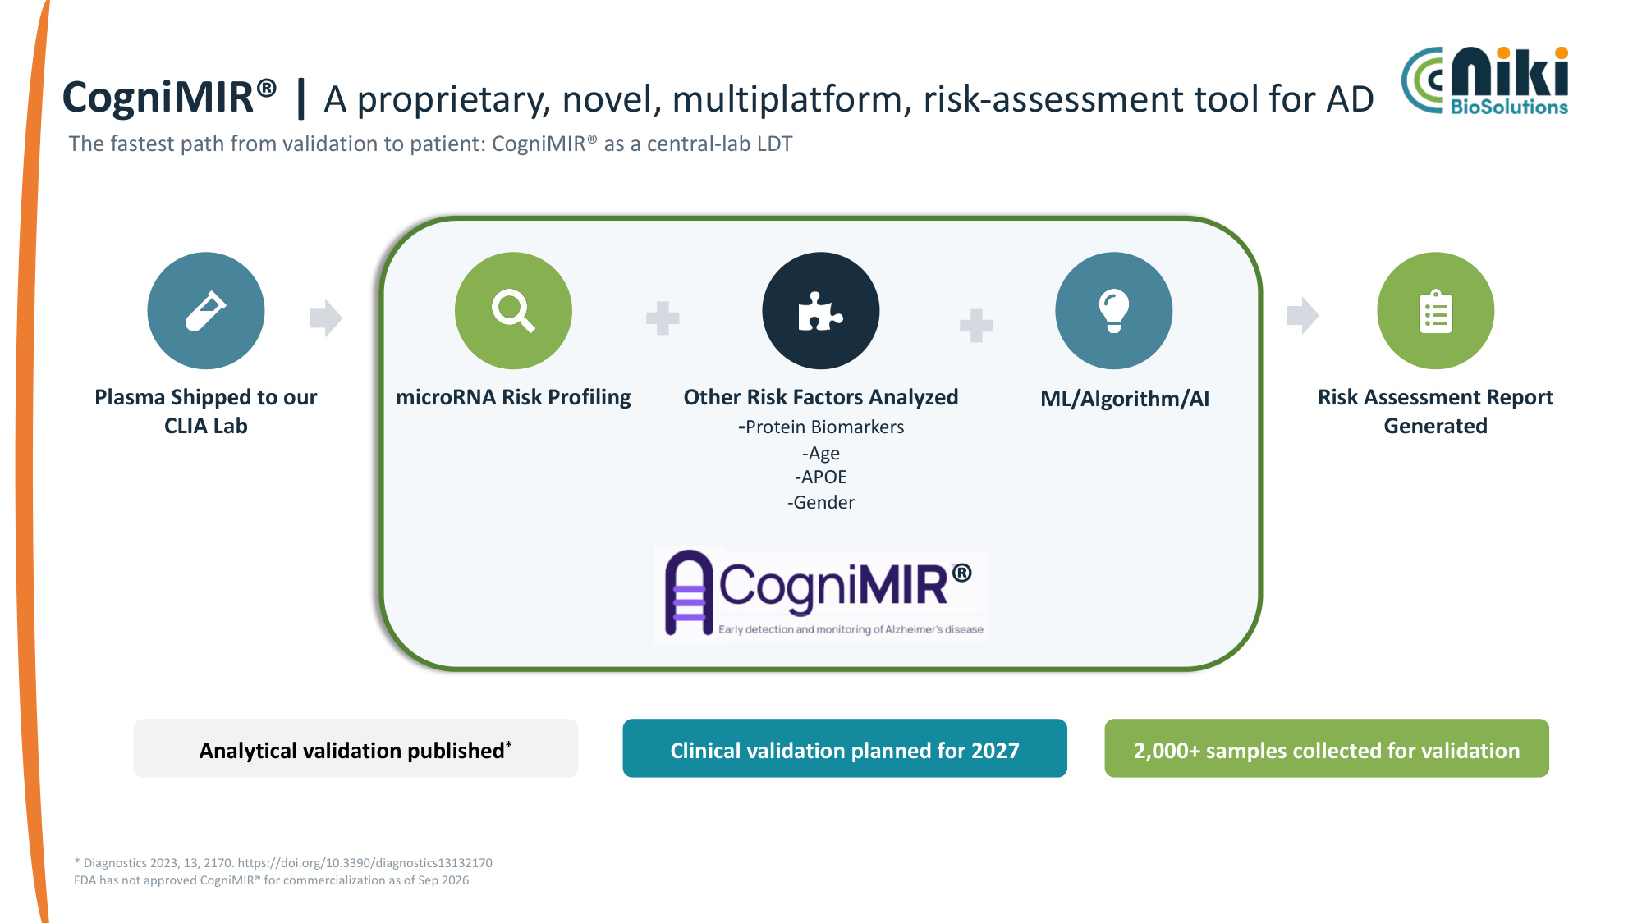
CogniMIR® | A proprietary, novel, multiplatform, risk-assessment tool for AD Plasma Shipped to our CLIA Lab microRNA Risk Profiling Other Risk Factors Analyzed -Protein Biomarkers -Age -APOE -Gender ML/Algorithm/AI Risk Assessment Report Generated * Diagnostics 2023, 13, 2170. https://doi.org/10.3390/diagnostics13132170 FDA has not approved CogniMIR® for commercialization as of Sep 2026 Analytical validation published* Clinical validation planned for 2027 2,000+ samples collected for validation ® The fastest path from validation to patient: CogniMIR® as a central-lab LDT

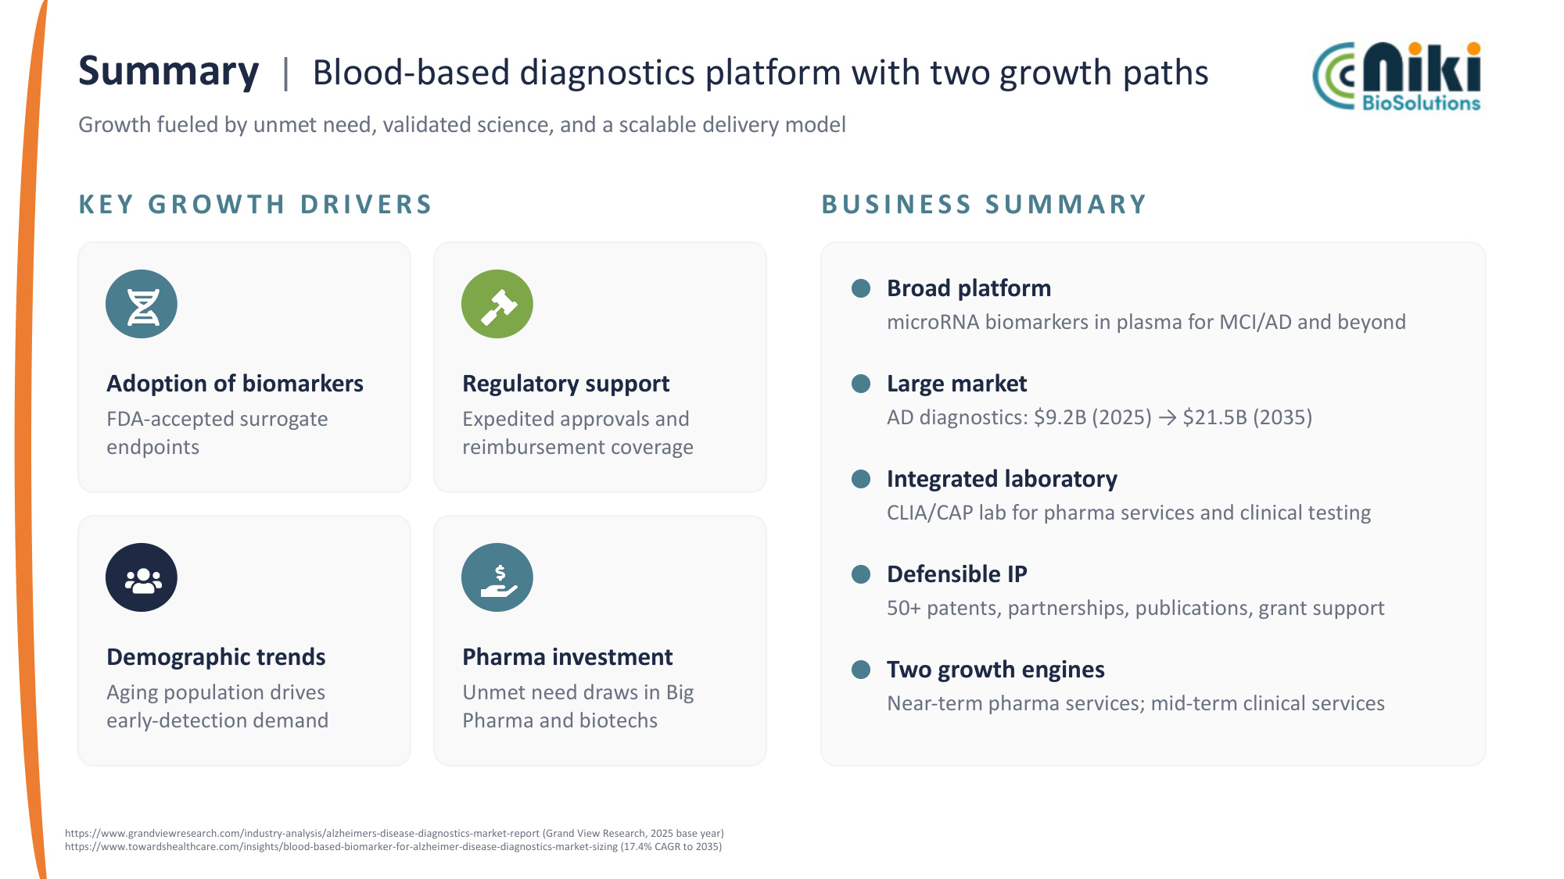
Summary | Blood-based diagnostics platform with two growth paths Growth fueled by unmet need, validated science, and a scalable delivery model KEY GROW TH DRIVERS Adoption of biomarkers FDA-accepted surrogate endpoints Regulatory support Expedited approvals and reimbursement coverage Demographic trends Aging population drives early-detection demand Pharma investment Unmet need draws in Big Pharma and biotechs BUSINESS SUMMARY Broad platform microRNA biomarkers in plasma for MCI/AD and beyond Large market AD diagnostics: $9.2B (2025) → $21.5B (2035) Integrated laboratory CLIA/CAP lab for pharma services and clinical testing Defensible IP 50+ patents, partnerships, publications, grant support Two growth engines Near-term pharma services; mid-term clinical services https://www.grandviewresearch.com/industry-analysis/alzheimers-disease-diagnostics-market-report (Grand View Research, 2025 base year) https://www.towardshealthcare.com/insights/blood-based-biomarker-for-alzheimer-disease-diagnostics-market-sizing (17.4% CAGR to 2035)


Thank You – Q&A Investor relations contact information: Lytham Partners shamsian@lythampartners.com

